**DAILY ONLINE ACTIVITIES SUMMARY**

|  |  |  |  |  |  |  |  |  |
| --- | --- | --- | --- | --- | --- | --- | --- | --- |
| **Date:** | **29/05/2020** | | | | | **Name:** | **SUJANA** | |
| **Sem & Sec** | **IV sem & B section** | | | | | **USN:** | **4AL18CS089** | |
| **Online Test Summary** | | | | | | | | |
| **Subject** | | **Operating Systems** | | | | | | |
| **Max. Marks** | | **30** | | **Score** | | | **28** | |
| **Certification Course Summary** | | | | | | | | |
| **Course** | **Python For Machine Learning** | | | | | | | |
| **Certificate Provider** | | | **Greatlearning academy** | | **Duration** | | | **5.0 hours** |
| **Coding Challenges** | | | | | | | | |
| **Problem Statement1:** Write a Java program to Find size of the largest ‘+’ formed by all ones in a binary matrix  **Problem Statement2:** Write a C Program to generate first N Armstrong Numbers | | | | | | | | |
| **Status: Executed** | | | | | | | | |
| **Uploaded the report in Github** | | | | | **YES** | | | |
| **If yes Repository name** | | | | | **Online-coding** | | | |
| **Uploaded the report in slack** | | | | | **YES** | | | |

Online Test Summary: 18CS43(OS) test was scheduled from 9:00 am t0 9:45am .The portion for the IA was 2nd module there were 30 questions and the time assigned was 30 minutes the questions were of mcq type.

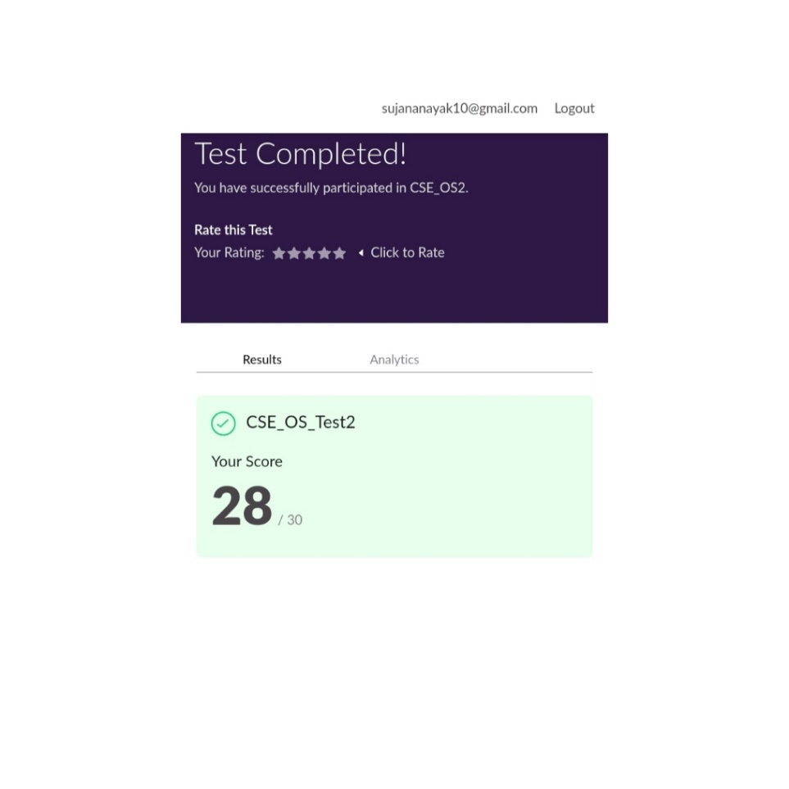

This is the snap shot of completion of test and the marks obtained.

Online Certification Course Summary: In today’s session I have learnt about user defined functions in python

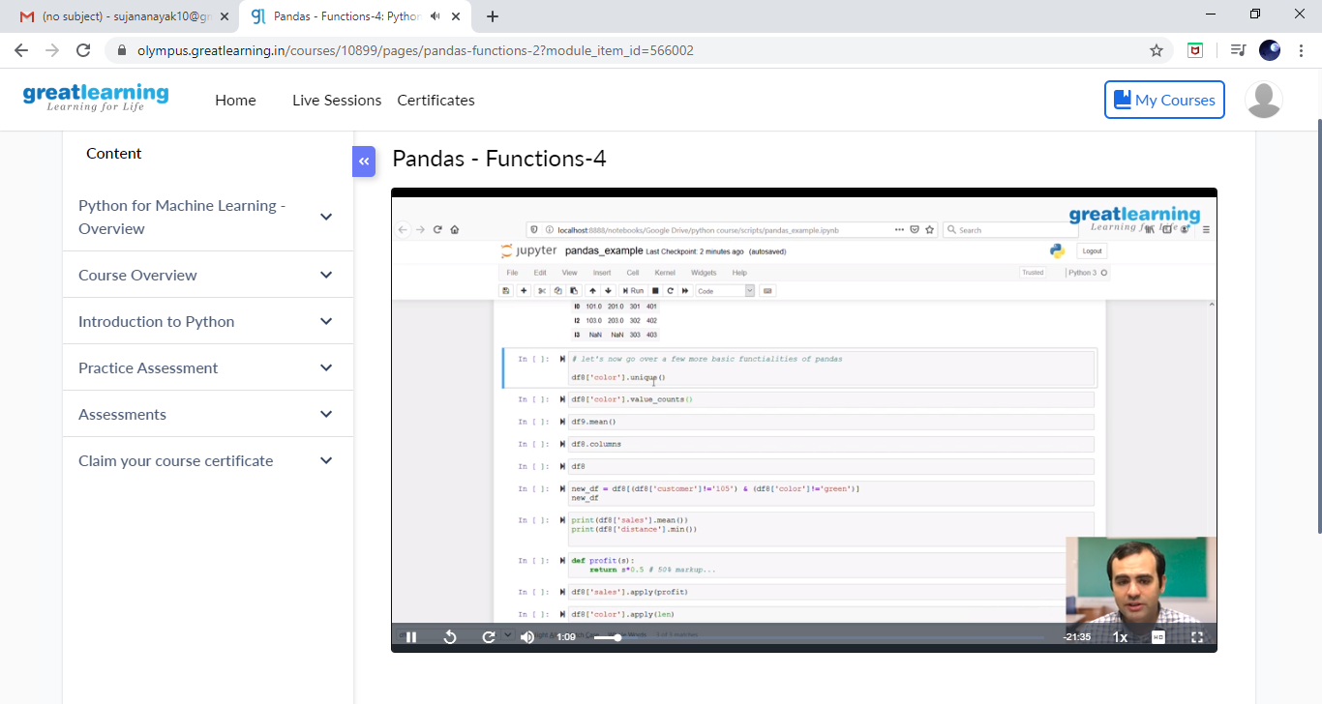

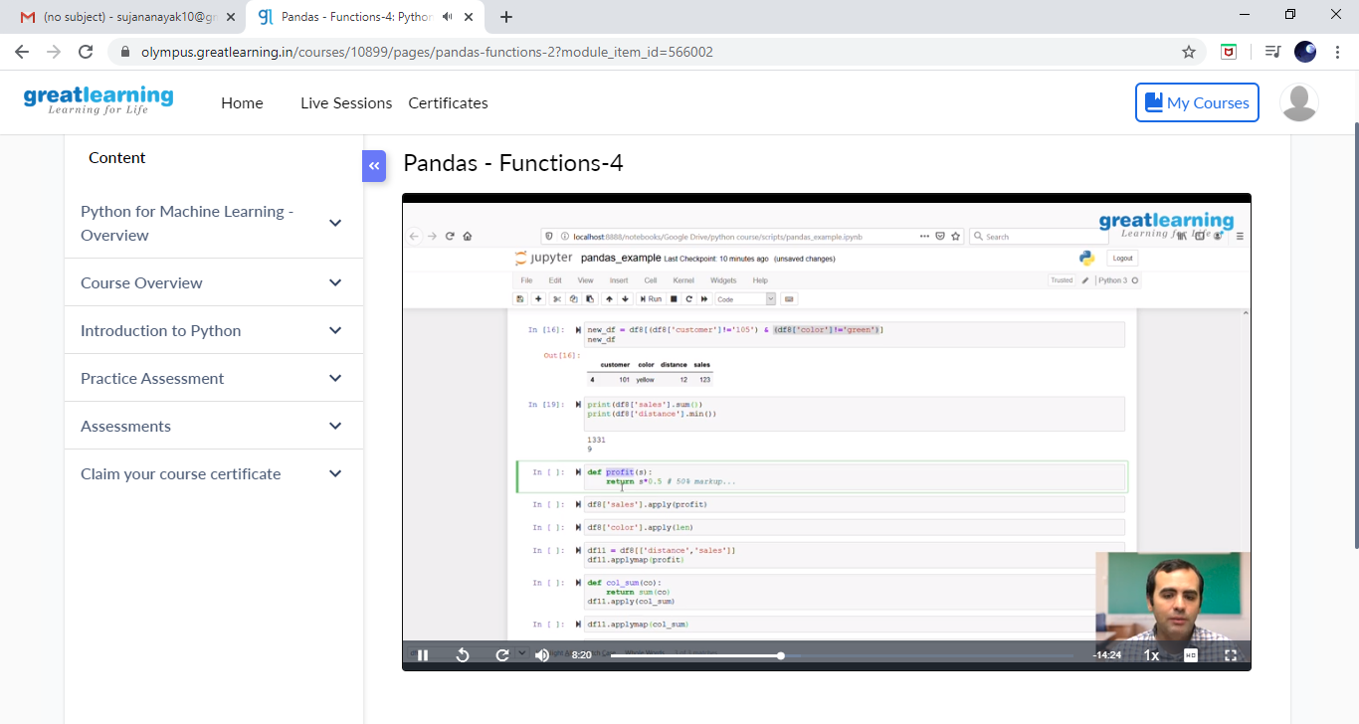

These are the snap shots of today’s session

Online Coding Summary: **Today I had received one program from prof. Shilpa CSE Dept. and the other from Prof. Venkatesh CSE Dept. The program is mentioned above in the coding challenges. I have also uploaded it to my Github repository.**

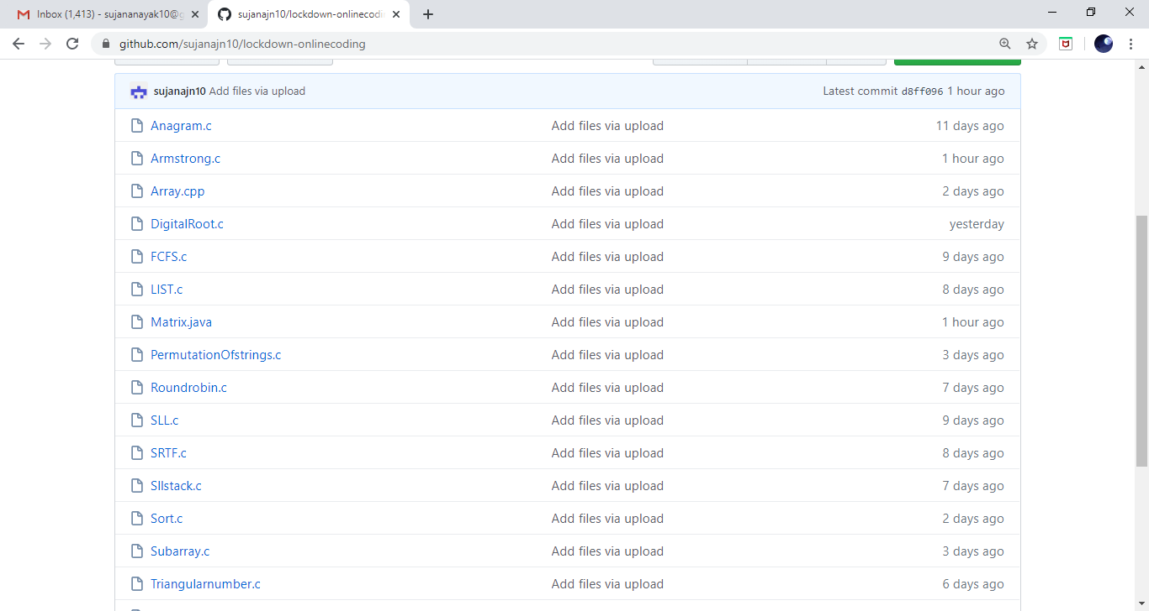

**This is the snap shot of my Github repository** were I have uploaded the code. File name is A.java and Armstrong.c